GHWG SPRING COMPETITION RULES

- There are 3 SKILL LEVEL CLASSES, defined as follows:
  - NOVICE*: a beginner turner who has been turning for 4 years or less.
  - INTERMEDIATE*: a turner who has turned for more than 2 years but does not consider her/himself to be an advanced turner
  - OPEN: any turner who wishes to enter a more skilled competition, excluding segmented pieces.

There are 2 SIZE CATEGORIES for the novice, intermediate and open classes:
  - SMALL: any piece that WILL fit within a 4” x 4” x 8” box. This includes both spindle and faceplate/chuck work.
  - LARGE: any piece that WILL NOT fit within a 4” x 4” x 8” box. This includes both spindle and faceplate/chuck work.
  - NOTE: A piece must fit into a 4” x 4” x 8” box in it’s fully assembled/as-presented state (i.e. not disassembled).

There are no SKILL LEVEL CLASSES or SIZE CATEGORIES for segmented entries:
  - SEGMENTED entries include pieces of any size or shape, by any skill level entrant.

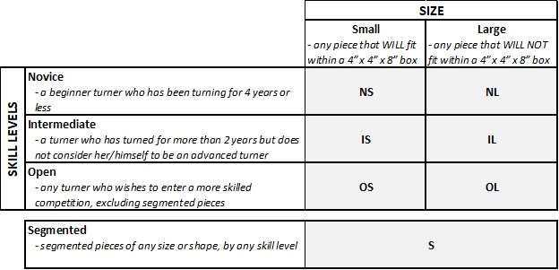

In addition to the above, the following rules will apply to all entries:
- An entry must have been completed no more than one calendar year prior to the current competition.
- A competitor may enter a maximum of two pieces in the competition.
- All entries must include a significant turned element and may be functional, artistic or any combination of the two. Any wood species or turnable material may be used.

*Please note:
- A NOVICE turner who has won 1st place in a previous GHWG competition need not move to the INTERMEDIATE Class unless she/he wishes to (up to the 4 year limit).
- Any INTERMEDIATE turner who has won 1st place in a previous GHWG competition must move
to the OPEN Class for subsequent competitions

