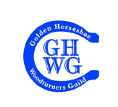
GHWG SPRING COMPETITION RULES

- There are 3 SKILL LEVEL CLASSES, defined as follows:
  - NOVICE: a beginner turner who has been turning for 4 years or less.
  - INTERMEDIATE: a turner who has turned for more than 2 years but does not consider her/himself to be an advanced turner
  - OPEN: any turner who wishes to enter a more skilled competition, excluding segmented pieces.

There are 2 SIZE CATEGORIES for the novice, intermediate and open classes:
  - SMALL: any piece that WILL fit within a 4” x 4” x 8” box. This includes both spindle and faceplate/chuck work.
  - LARGE: any piece that WILL NOT fit within a 4” x 4” x 8” box. This includes both spindle and faceplate/chuck work.

There are no SKILL LEVEL CLASSES or SIZE CATEGORIES for segmented entries:
  - SEGMENTED entries include pieces of any size or shape, by any skill level entrant.

In addition to the above, the following rules will apply to all entries:
- An entry must have been completed no more than one calendar year prior to the current competition.
- A competitor may enter a maximum of two pieces in the competition.
- All entries must include a significant turned element and may be functional, artistic or any combination of the two. Any wood species or turnable material may be used.

Please note:
- A NOVICE turner who has won 1st place in a previous GHWG competition need not move to the INTERMEDIATE Class unless she/he wishes to (up to the 4 year limit).
- Any INTERMEDIATE turner who has won 1st place in a previous GHWG competition must move
to the OPEN Class for subsequent competitions.

GHWG 2021 VIRTUAL COMPETITION GUIDELINES

- Active members are invited to submit a maximum of two (2) entries to our virtual 2021 Spring Competition. The rules for this virtual competition are the same as for every competition, please see above.
- The competition will open on Sunday May 2nd, 2021. The deadline for submitting entries is Thursday May 20th. This gives you just about three (3) weeks to submit your pieces.
- The entries should be forwarded by e-mail to the club photographer, Maurice Solar, at mal4.ms.ghwg@gmail.com. Each entry would consist of one of the following:
- One picture (and only one) of each entry accompanied by a completed entry form (available on the Spring Competition web page, under the Members Only section). It is suggested that the picture(s) be taken against a neutral, uniform background so that the surroundings will not distract from the piece(s) submitted. A blank, freshly ironed sheet will do.
- The reason for limiting each entry to only one picture is that we will use our new website to post the pictures and carry out the voting. So please use your best picture for the piece(s) you submit.
- Some members may not have the means to scan a completed entry form. In which case they can simply send an e-mail using the following as an example:

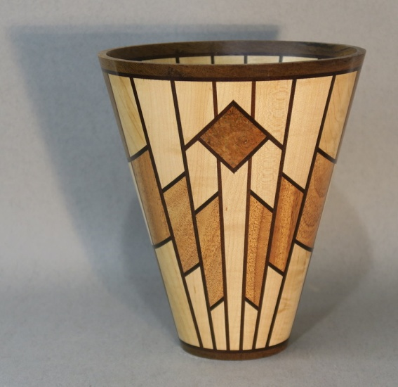
Name: Maurice Solar
Membership No: 669
Title (if any): The Sconce
Description: Vase
Category: Segmented
Woods: Maple, mahogany, nogal and teak
Dimensions: 8"H x 7" D
Finish: Mylands High Build Friction Polish
Buffed with Beall system

- Maurice will edit the pictures and prepare them for upload to the club's new website. Each picture will be referenced by an entry number: NS and NL for Novice Small and Large, IS and IL for Intermediate Small and Large, OS and OL for Open Small and Large, and S for Segmented. These initials will be followed by a number specific to each entry.
- Once the deadline of May 20st has passed, the pictures will be uploaded to the club website by May 27th. The webmaster will email you instructions on how to vote. The voting will be conducted online. You will have one (1) week to submit your vote. Voting (or Polling as it is called on our website) will close Thursday June 3rd at midnight.
- The votes will be tabulated and the winners in each category selected.
- An independent, outside judge (probably the president of another club) will select the "Most Promising Novice" and "Best in Show".
- ALL the novice entries will be sent to that independent judge for selection of the Most Promising Novice, who will eventually receive the Doug Newlove trophy (once we can arrange the relay).
- ONLY the first-place winners of the Intermediate (S and L), Open (S and L) and Segmented categories will be forwarded to the independent judge for selection of Best in Show (meaning only five entries, unless there are ties for 1st place). This follows the practice we initiated last year.
- The winners will be announced during our regular meeting on Thursday June 10th.

